Building the PGSuper Installer

Written By: | RAB | Creation Date: | 10/27/2005
Reviewed By: |  | Last Revised: | 08/21/2012
Project: | PGSuper | WI # | <<#>>
 |  | Version | 1.0 - Draft

Purpose
The purpose of this work instruction is to describe how to build the PGSuper installer in InstallShield 11.

Preconditions
The following conditions are assumed:
- The dependent WBFL merge module has been created WBFL has been built
- All files that contain the __DATE__ macro have been forced to be re-compiled (the easiest way to do this is to open the file, create a blank link by hitting the Enter key, deleting the blank line, and saving the file)
- All regression tests have been run and the software has been validated
- All of the PGSuper Release build projects have been complied
- The batch procedure UpdateBinFiles.bat is up to date
- The following files are available (these are the objective grid files and should be found in \ARP_RELEASE\Grid\<platform>)
wsdot_og1204as.dll
wsdot_og1204asu.dll
RWUXThemeS90.dll
RWUXThemeSU90.dll
sfl504as.dll
sfl504asu.dll

Procedure
Follow this procedure:

- Run the UpdateBinFiles.bat procedure to move all of the release files into the appropriate subdirectories of the bin folder. Do this for both PGSuper and WBFL.
- Commit both PGSuper and WBFL
- In the ARP_RELEASES\WBFL folder do a CVS Check Out. On the TortoiseCVS Options tab, select “Export” and “Enter your own folder name”. Use the x.y.z.b version number (3.5.0.4) as the folder name.
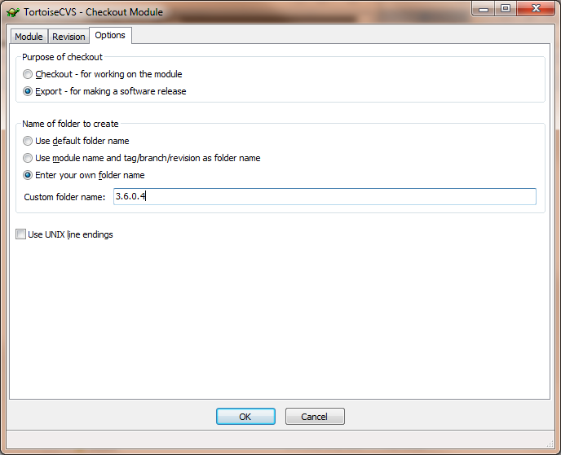
After the check out is complete, go into the \ARP_RELEASES\WBFL\x.y.z.b folder and create a folder called “src”. Copy everything into the “src” folder EXCEPT the “bin” folder. WBFL is now ready to be put into the installer backage and the source files are located property for the source code installers.
- In the ARP_RELEASES\PGSuper folder do a CVS Check Out. On the TortoiseCVS Options tab, select “Export” and “Enter your own folder name”. Use the x.y.z.b version number (3.5.0.4) as the folder name. After the check out is complete, go into the \ARP_RELEASES\PGSuper\x.y.z.b folder and create a folder called “src”. Copy everything into the “src” folder EXCEPT the “bin” folder. PGSuper is now ready to be put into the installer backage and the source files are located property for the source code installers.
- Open the “PGSuper.ism” file in InstallShield 11.
- Select the “Installation Designer” tab
- In the tree view on the left, select Installation Information then General Information
- Update the Product Version field
- In the tree view on the left, select Media and Path Variables
- Update the version numbers in the path variables. For example, change the version number in PATH_TO_APP_FILES to the current version number.
- In the tree view on the left, select Media and Releases
- Select the release project to build
- For that release project, updated the MSI Package file name (every MSI should have a unique name)
- Press the Build button on the toolbar to build the installer. The installer file will be created in the \ARP_INSTALLER folder.
- Test the installer

After the Installer is finalized
After the installer is finalized, there are several steps that must be taken to prepare WBFL and PGSuper for further development.
- If this is a release from the HEAD branch, run the CVS branch command on WBFL and PGSuper. The label for the patches branch is “version-x-y-z-patches”.
- Tag the WBFL and PGSuper source code in CVS on the branch that you are releasing from. The tag shall be “release-x-y-z-b” for final releases and “release-x-y-z-b-beta” for beta releases. x, y, z, and b are from the version and build numbers.
- After the tagging process is complete, update the version numbers in all resource files and regression test results. Do this on both the head and patches branch.
  - WBFL – Run the UpdateProductVersionNumber macro in DevStudio. Select the WBFL option
  - PGSuper – Run the UpdateProductVersionNumber macro in DevStudio. Select the PGSuper option. Also, run the mreplace.exe utility to change the version number (which is the process ID) in the regression test results file.
- After the version numbers are updated, commit WBFL and PGSuper. You are now ready to develop new features on the head branch and make bug fixes and tweaks on the patches branch.

